**Science Quest**

**User Manual**



**Start-up**

1. Firstly, when logged onto a computer open up the **student share** folder.
2. Within this folder open the **ICT** folder.
3. Find the folder labelled, ‘**Science Quest_A Level Project**’:

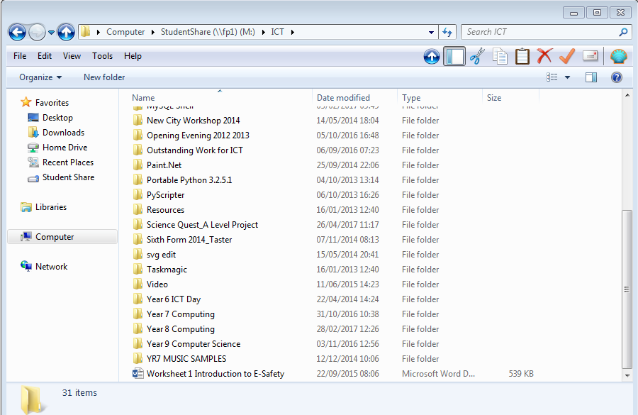

1. When in this folder click on **Science Quest.jar** to start the game. This option is shown by the battery icon:

If at any point in the game you are unable to continue (this could be due to an unforeseen bug or crash in the early version, please close the application and press on **Science Quest.jar** to start the program from the beginning.

**Controls**



**Left and right arrow keys**: These keys will move the robot in the corresponding direction.



**Enter key**: This key will allow you to interact with objects and other robots.



**Space key**: Pressing this key will make the robot jump.

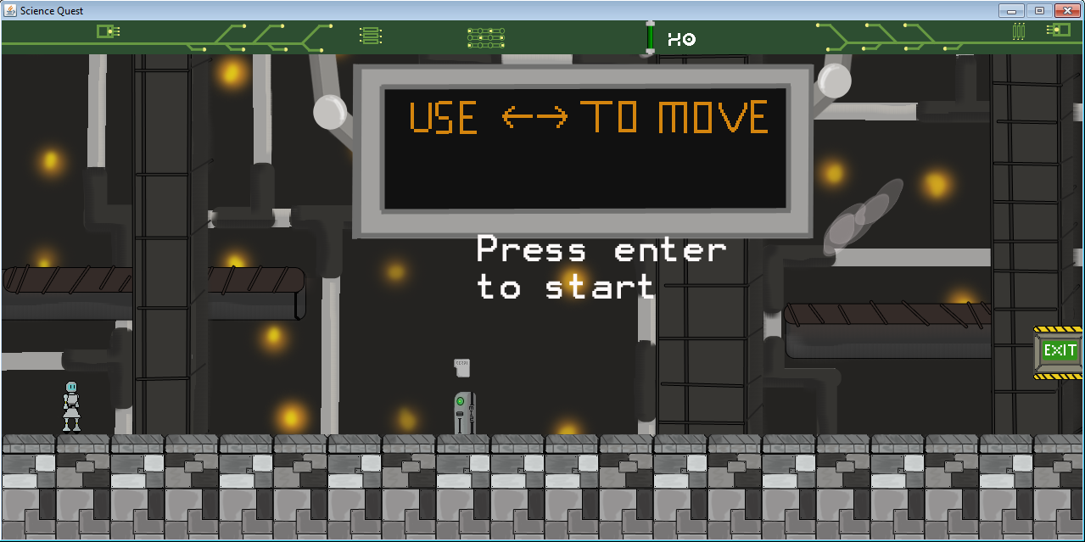**Screen Layout**

**3**

**1**

**1**

**4**

**2**

1. **Sherbet:** This is the main character of the game. It is up to you to control them to get to the end of each level.
2. **Object:** Objects litter your path and are the key to completing levels. Press the <enter> key once to interact with them and press then press it again to finish interacting. Some objects may either talk to you or cause Sherbet to talk, press enter to progress speech.
3. **Battery count:** Along your adventure you will come across batteries littered across the levels. This section will record how many batteries you have collected- try to find them all!
4. **Exit:** Reach the end of level to progress to the next one.